- Vyřešte celkový odpor zapojení.
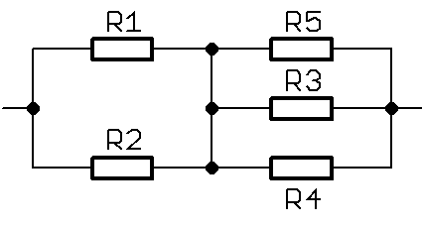
R₁=47; R₂=470; R₃=1k; R₄=68; R₅=68
1/Ra= 1/R1 + 1/R2 = ( R1+R2)/ R1xR2= (47+470)/47x470=517/22090=1/0,0234042553191489=
=42,72727272727279 Ohm.
1/Rb= (R3+R4+R5)/R3xR4xR5= (1000+68+68)/1000x68x68 = 1136/4 624 000= 1/2,456747404844291x0,01=1/0,02456747=40,70423Ohm
Rc=Ra+Rb=42,72727272727279+40,70423=83,43150272727279 Ohm

